**Assignment 06 – WordPress CMS Website (Basic Pages)**

**Instructions for completing template:**Replace **[bracketed red text]** with the requested information or screen capture.  
Replace **bracketed red text with black text** and then remove the brackets.  
Do not include full screen shot images, or full screen shots that are reduced in size. Use a snippet tool to capture parts of the screen and insert those images into the template.  
Do not remove tags from this template. Please answer all questions.  
**Please do not alter the formatting or delete parts of this template.**  
Assignment questions are not as detailed as activity questions.   
The assignment is where you demonstrate understanding of the material.

**Part A - Student Information**

1. **Student Name: Abel Marin [A01]**
2. **Student Contact Information: marinabe1416@gmail.com (630) 608-8570 [A02]**
3. **What day and date did you start this assignment: Saturday February 15, 2020 [A03]**

**Go back to the instructions and begin work on part B.**

**Part B - Create 1 Shared Web Host WordPress CMS Website**

(1) Shared Web Host WordPress CMS Site Information:

Shared Web Host Name: [SiteGround] [B01]  
cPanel URL: [Enter cPanel URL here] [B02] *Only for hosts with separate URL for cPanel  
Shared Web Host or cPanel Username: [amarin13@mail.depaul.edu] [B03]   
Shared web host or cPanel Password: [Dbeu!315] [B04]  
Domain Name: [abelm.sgedu.site] [B05]  
In Directory Name: [assignment06] [B06]  
Website Admin Username: [ajmarin] [B07]  
Website Admin Password: [&AK@N4SfY@] [B08]  
Database Name: [wp548] [B09]  
Table Prefix: [wp6z_] [B10]  
WordPress CMS Website URL: [http://abelm.sgedu.site/assignment06] [Front End URL] [B11]

*Note: Please do not provide the Backend for B11 (above).*

-OR-

(2) Pantheon – WordPress CMS Site Information:

**Assignment Website Site Name:** **[Site Name here] [B01]**

**WEBSITE Admin Username:** **[Admin Username here] [B02]**

**WEBSITE Admin Password:** **[Admin Password here] [B03]**

**Pantheon Frontend Website URL:** **[Frontend website URL here] [B04]**

**Go back to the instructions and begin work on part C.  
  
Part C - Extend the WP Site Content**

1. SCREEN CAPTURE of the backend WordPress **[Dashboard > Home] [C01]  
   [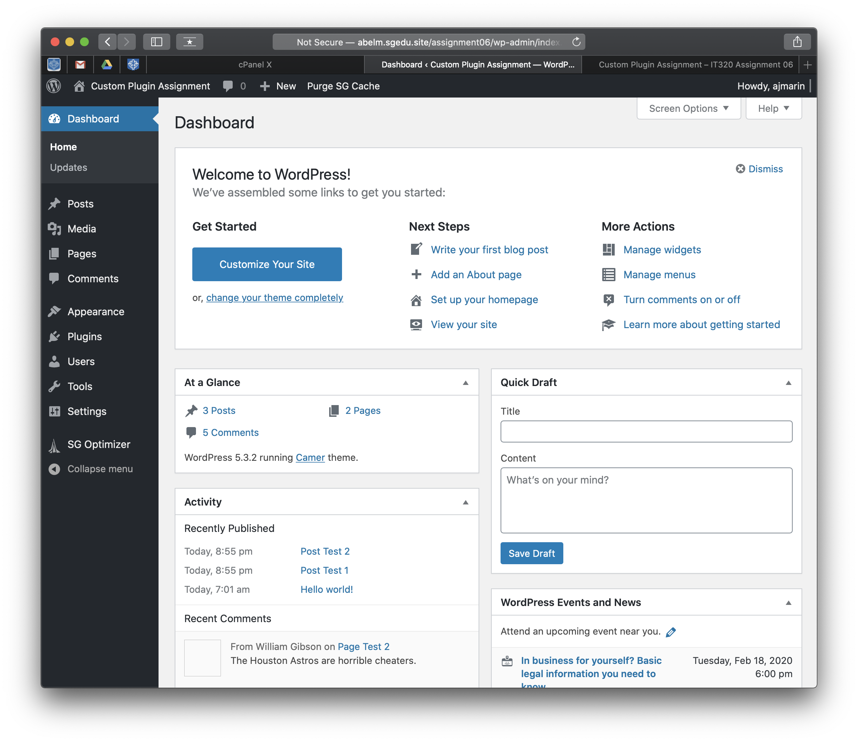]**
2. SCREEN CAPTURE of the backend WordPress **[Dashboard > Appearance] [C02]  
   [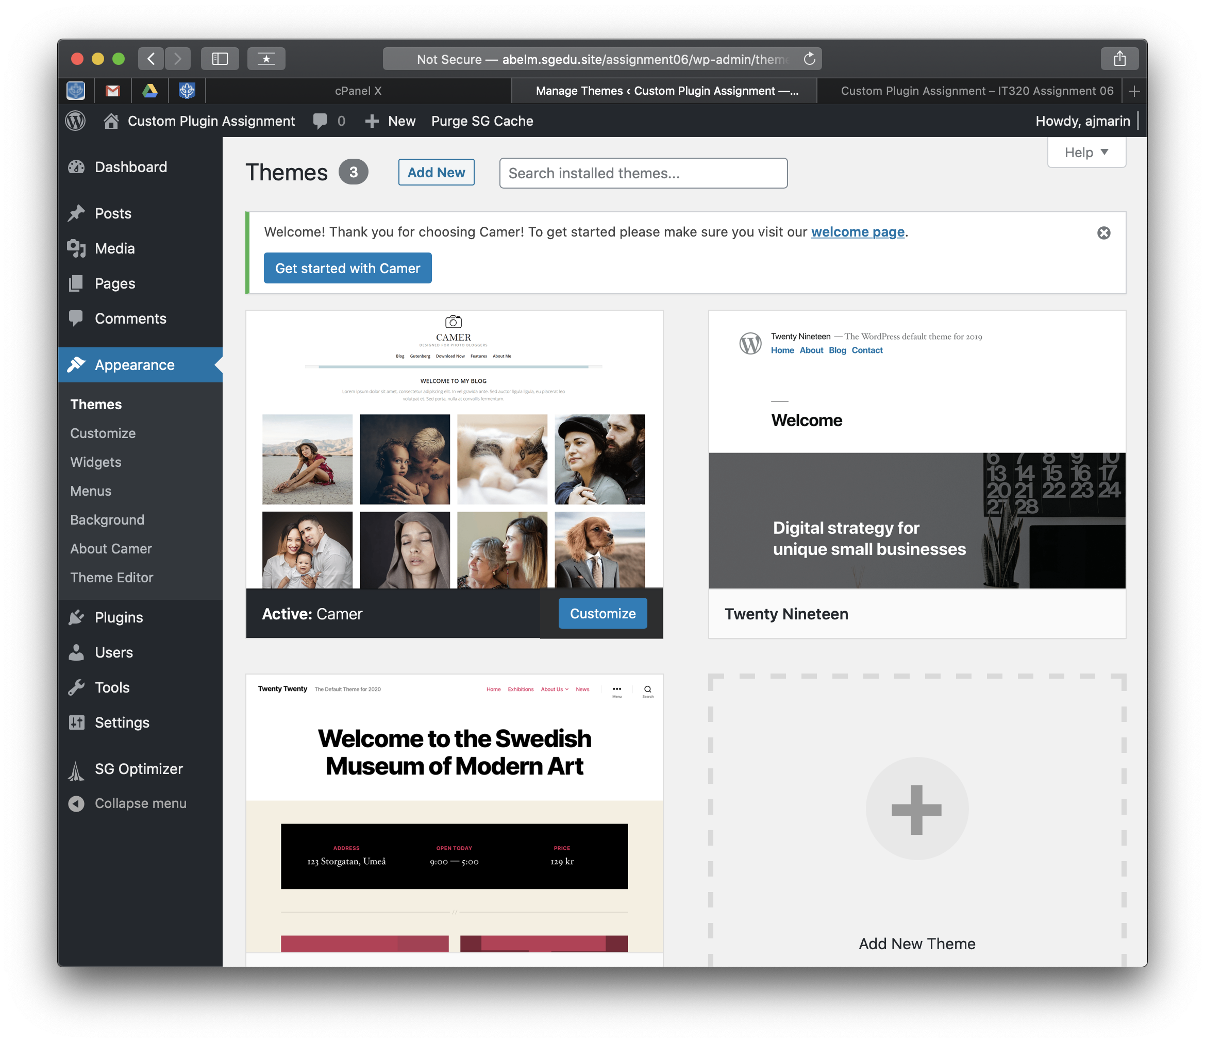]**
3. SCREEN CAPTURE of the backend WordPress **[Dashboard > Appearance > Menus] [C03]  
   [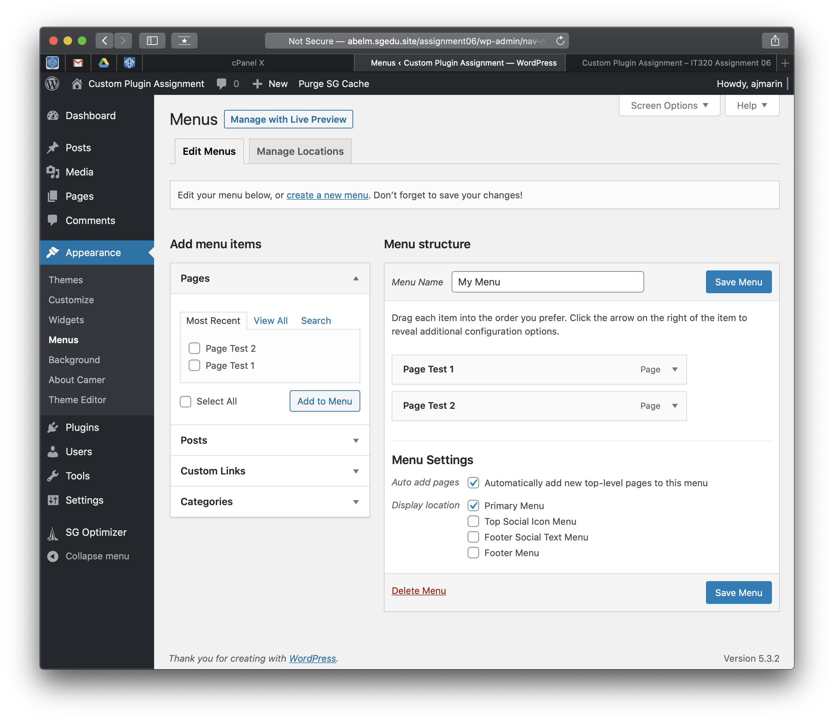]**
4. SCREEN CAPTURE of the backend WordPress **[Dashboard > Pages] [C04]  
   [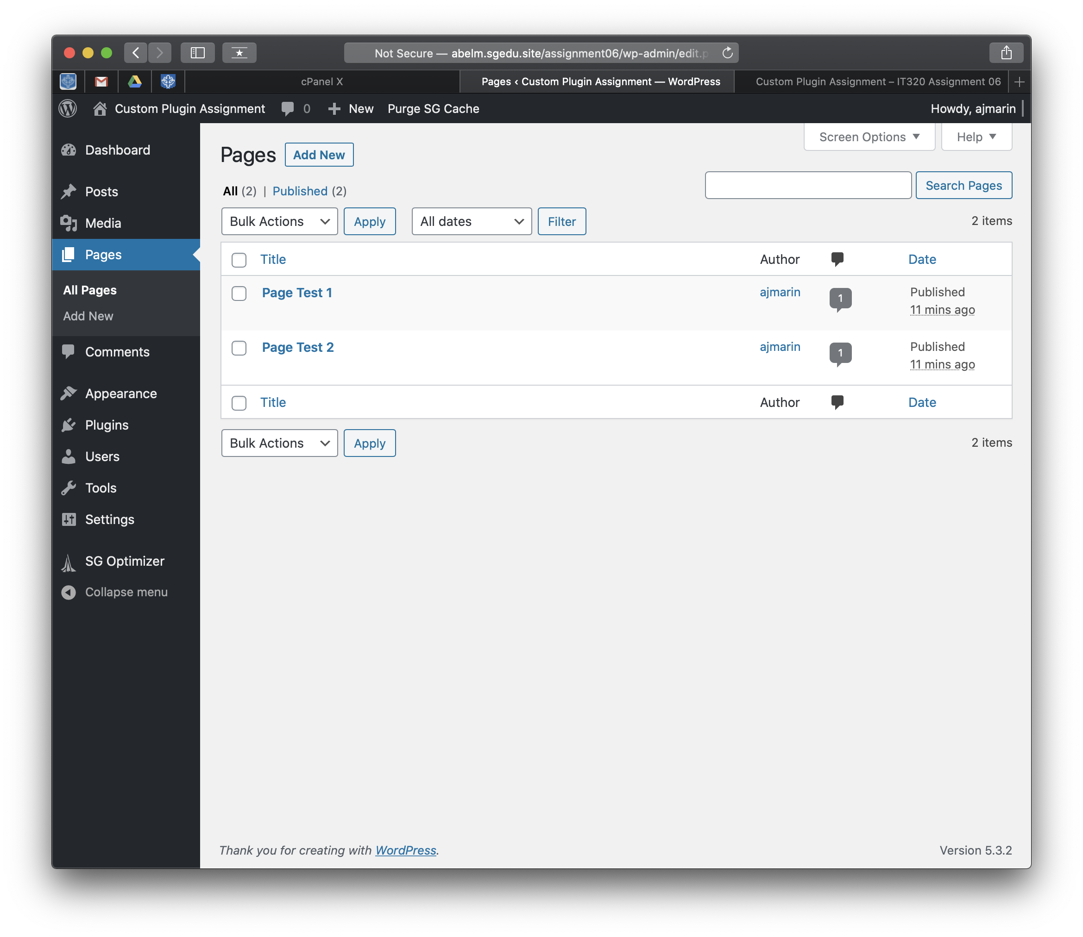]**
5. SCREEN CAPTURE of the backend WordPress **[Dashboard > Posts] [C05]  
   [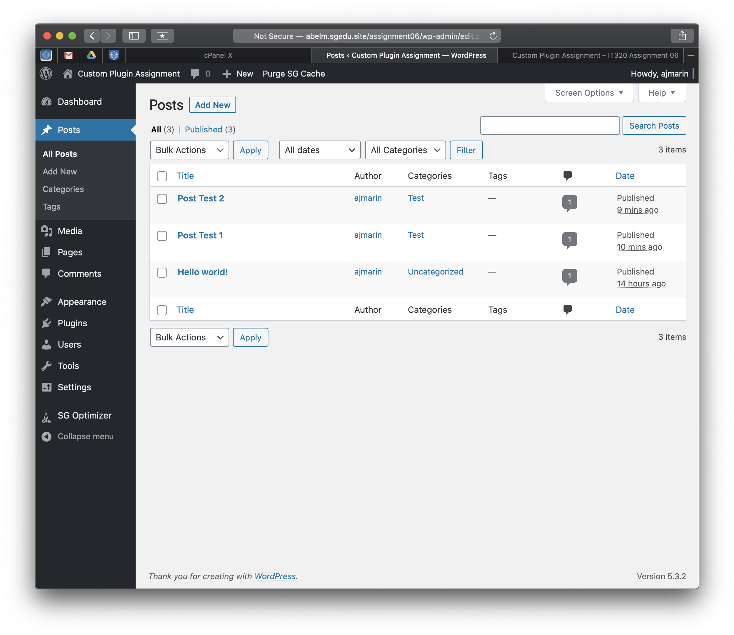]**

**Go back to the instructions and begin work on part D.**

**Part D – Create a new MySQL Table named Employee**

1. On phpMyAdmin, select the correct MySQL Database for this WordPress site
2. Select the employee table
3. Select the Structure TAB and take a SCREEN CAPTURE of the **Employee table structure  
    [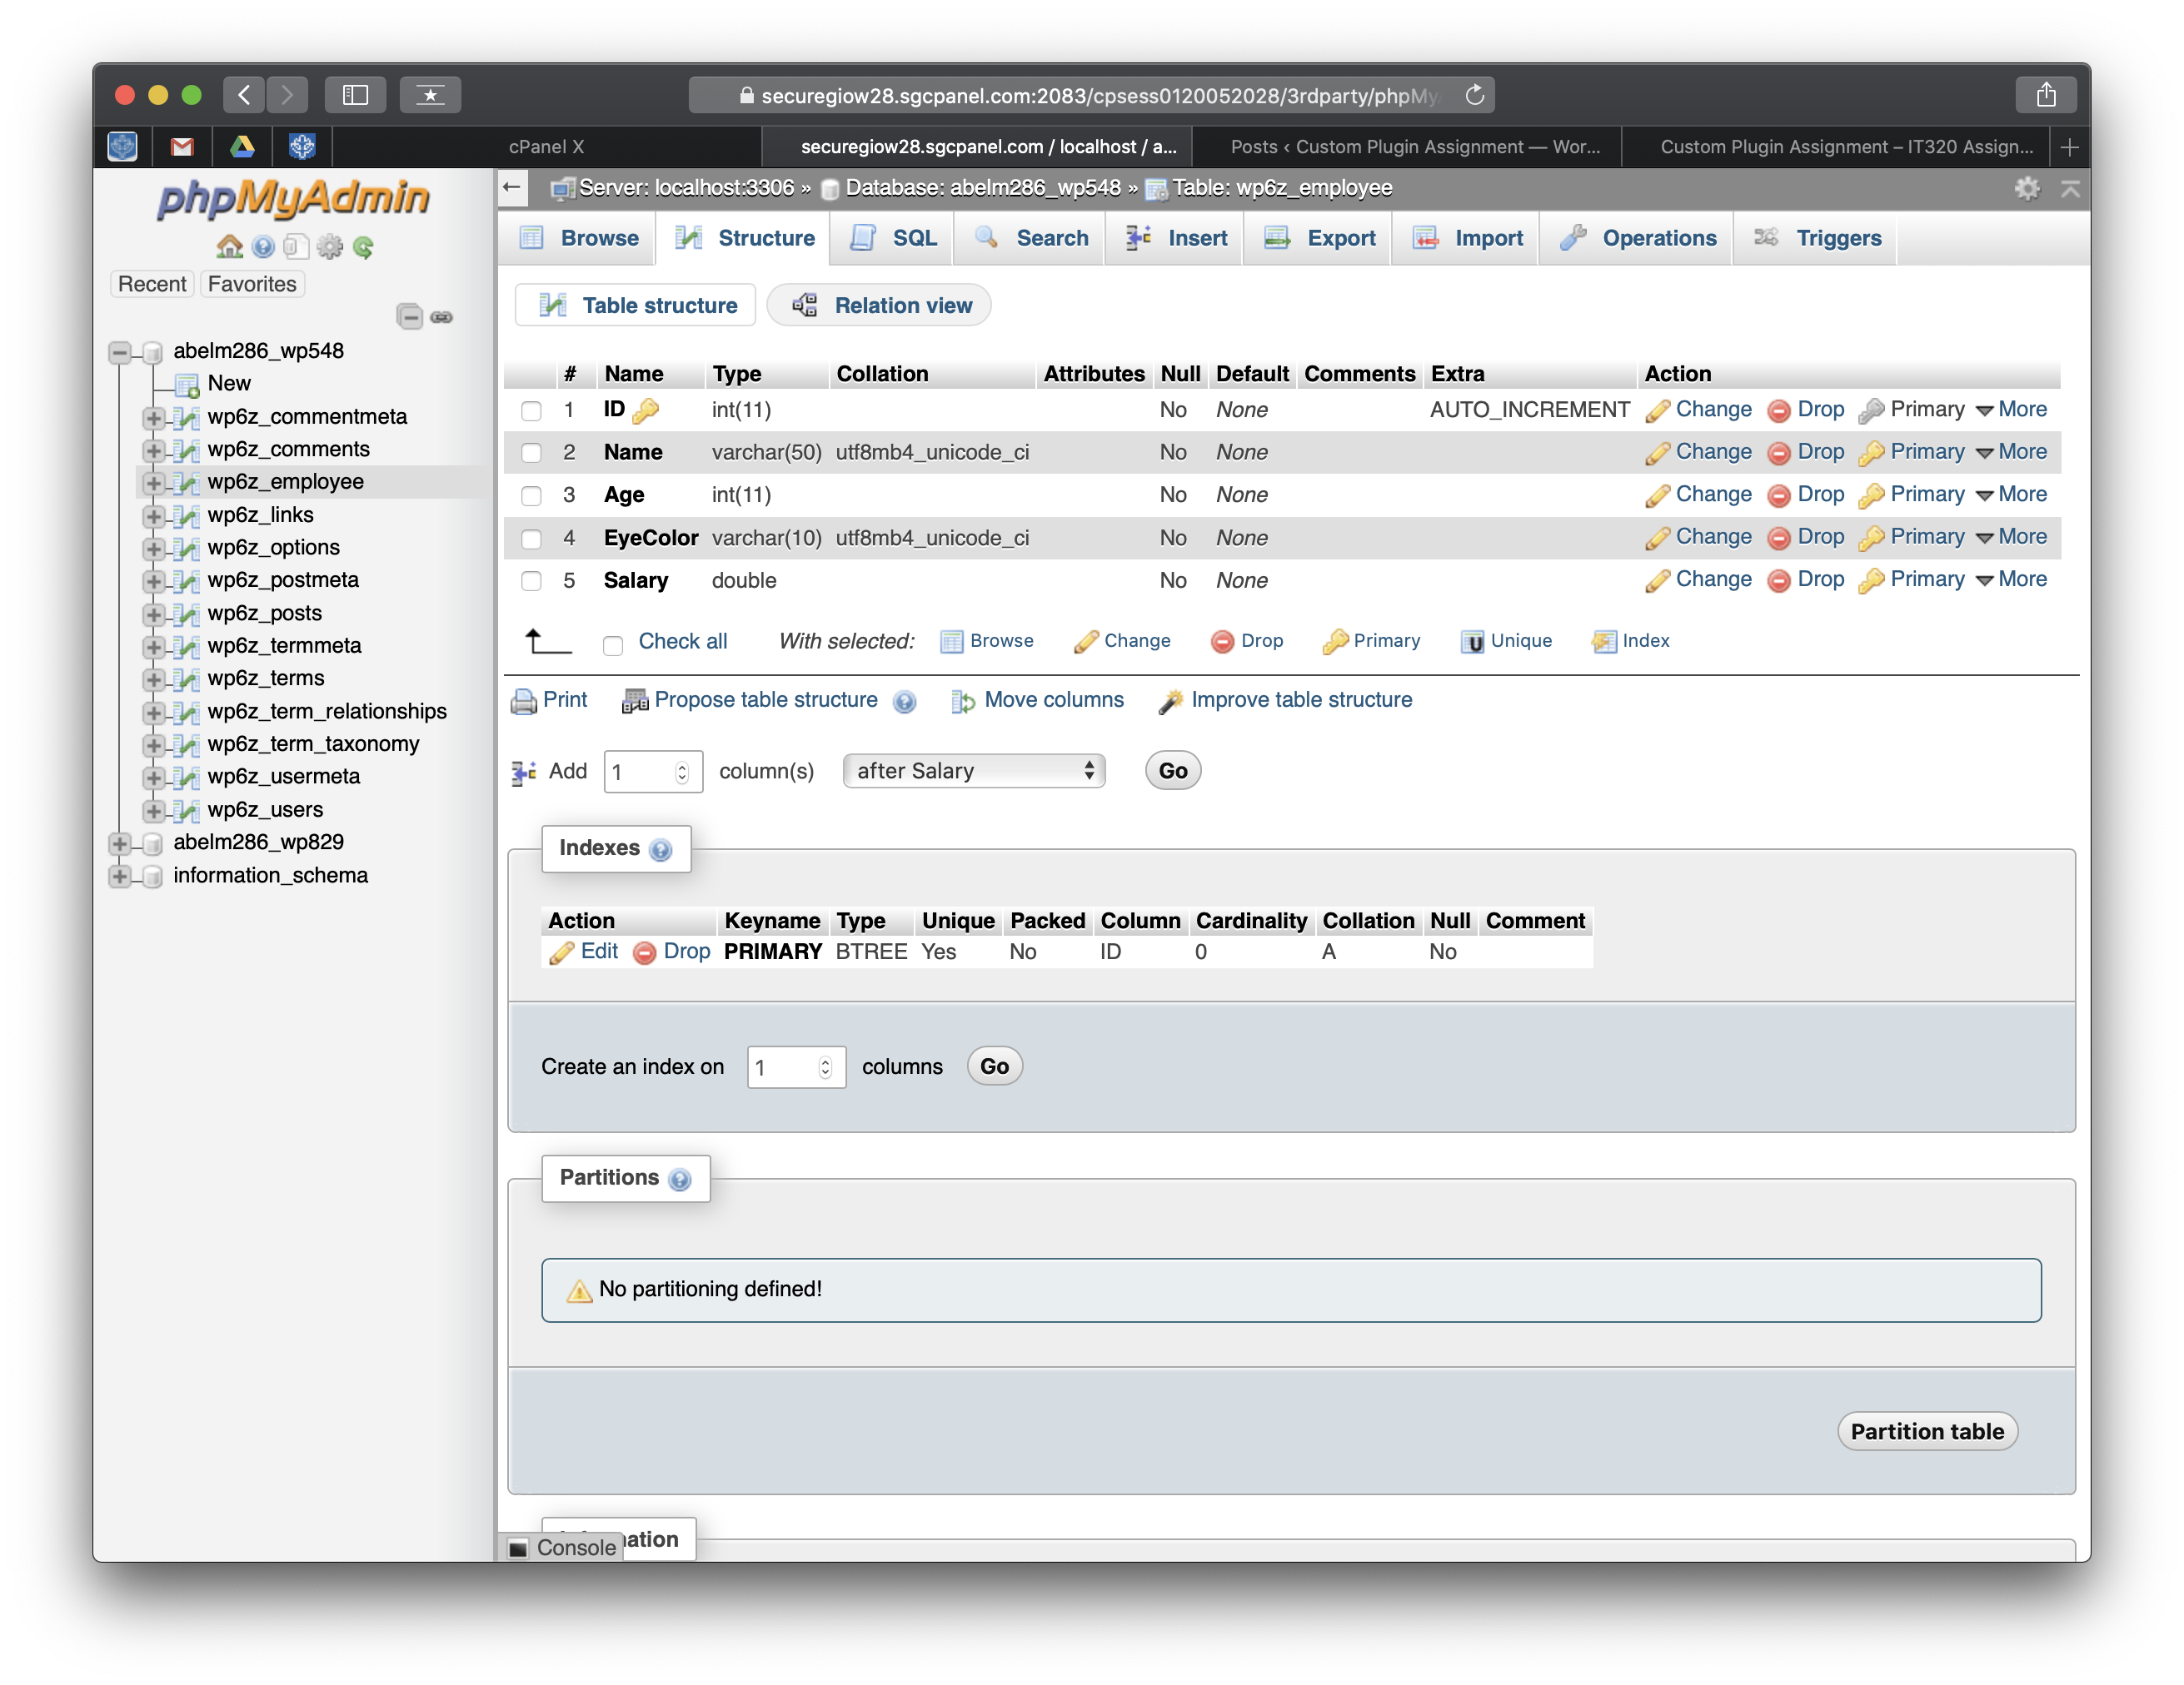] [D01]**

**Go back to the instructions and begin work on part E.**

**Part E: Add Records to the Employee table**

1. On phpMyAdmin, select the correct MySQL Database for this WordPress site
2. Select the employee table
3. Select the Browse TAB and take a SCREEN CAPTURE of the **employee table records[E01]  
    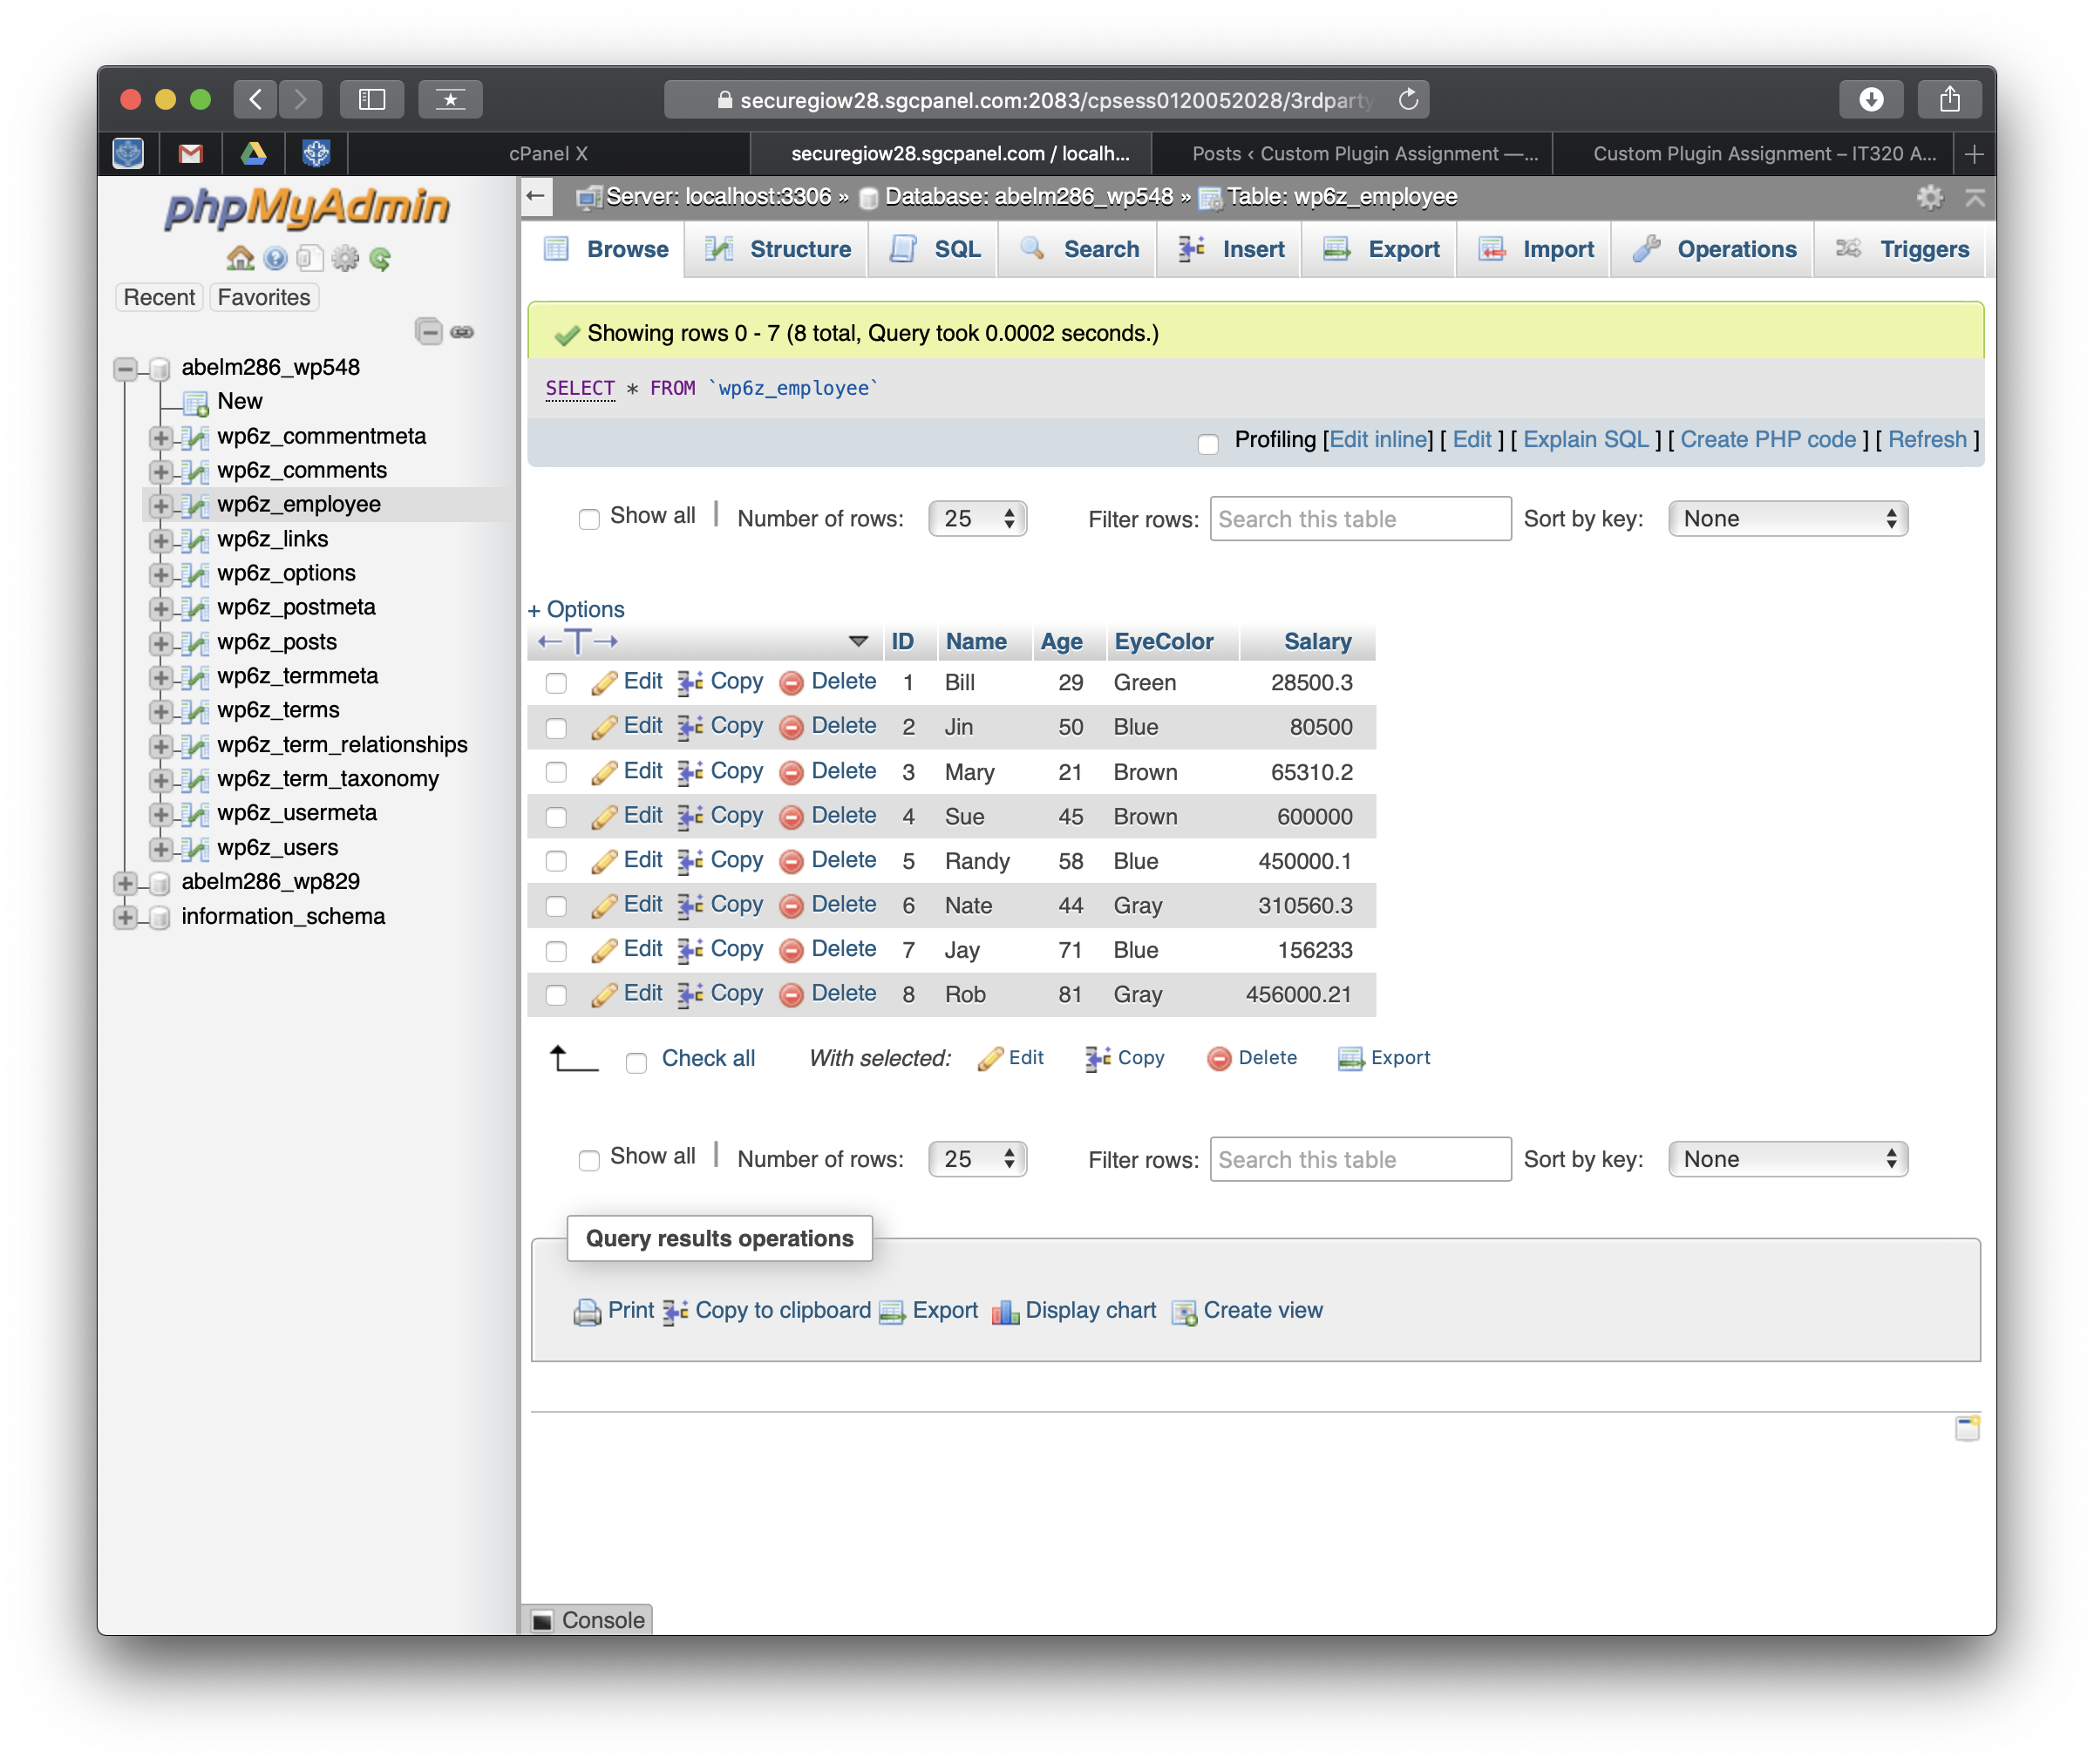[]**
4. Open the downloaded employee.sql backup file in an ASCII editor and take a screen capture of the .sql backup file contents. **[E02]**

**[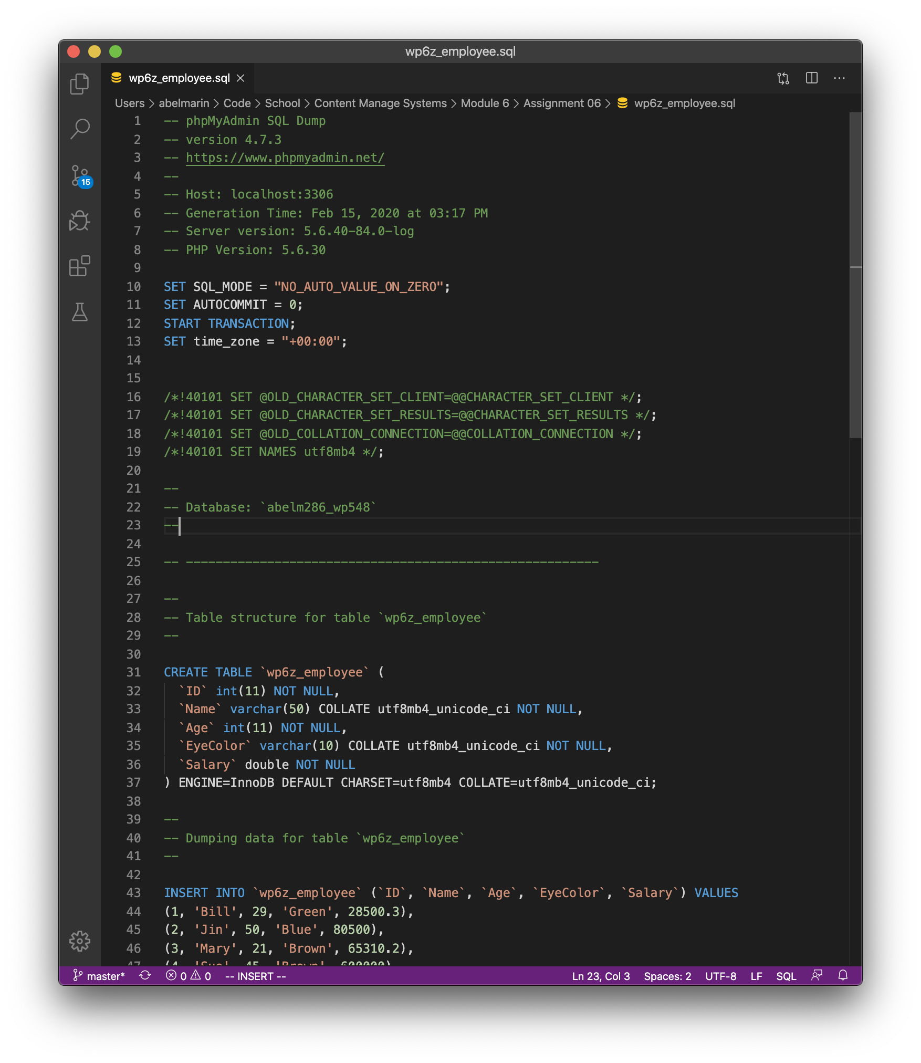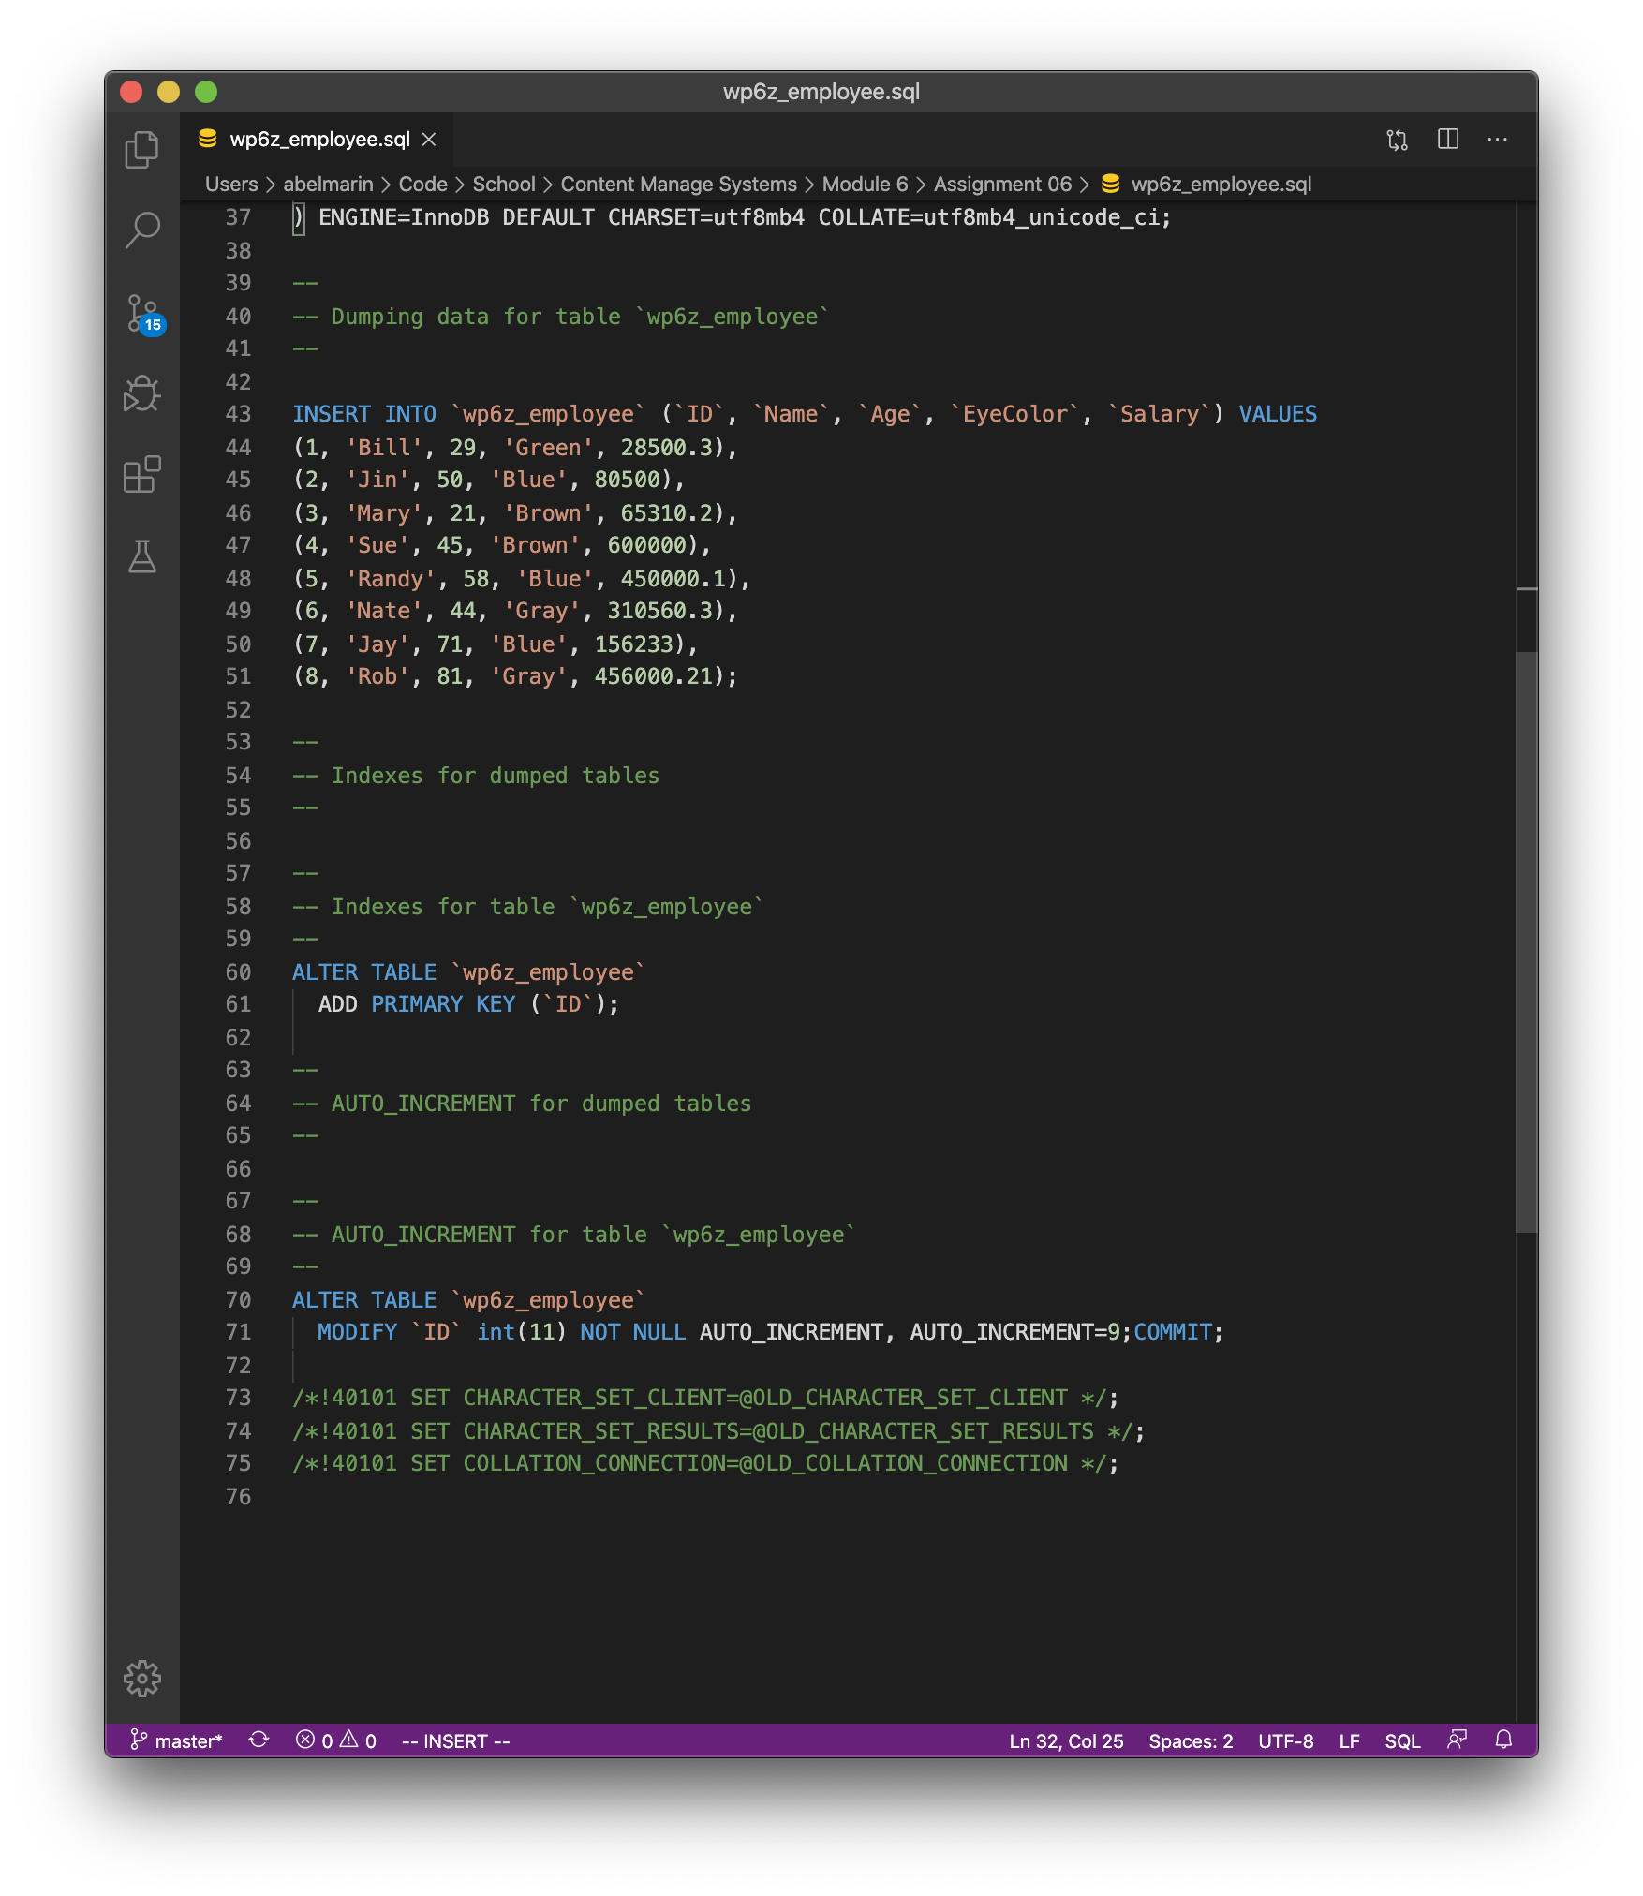]**

**Go back to the instructions and begin work on part F.**

**Part F - Create and deploy a WordPress Custom Plugin**

**1. Take a** SCREEN CAPTURE of the **backend** **[Dashboard > Plugins] [F01]  
[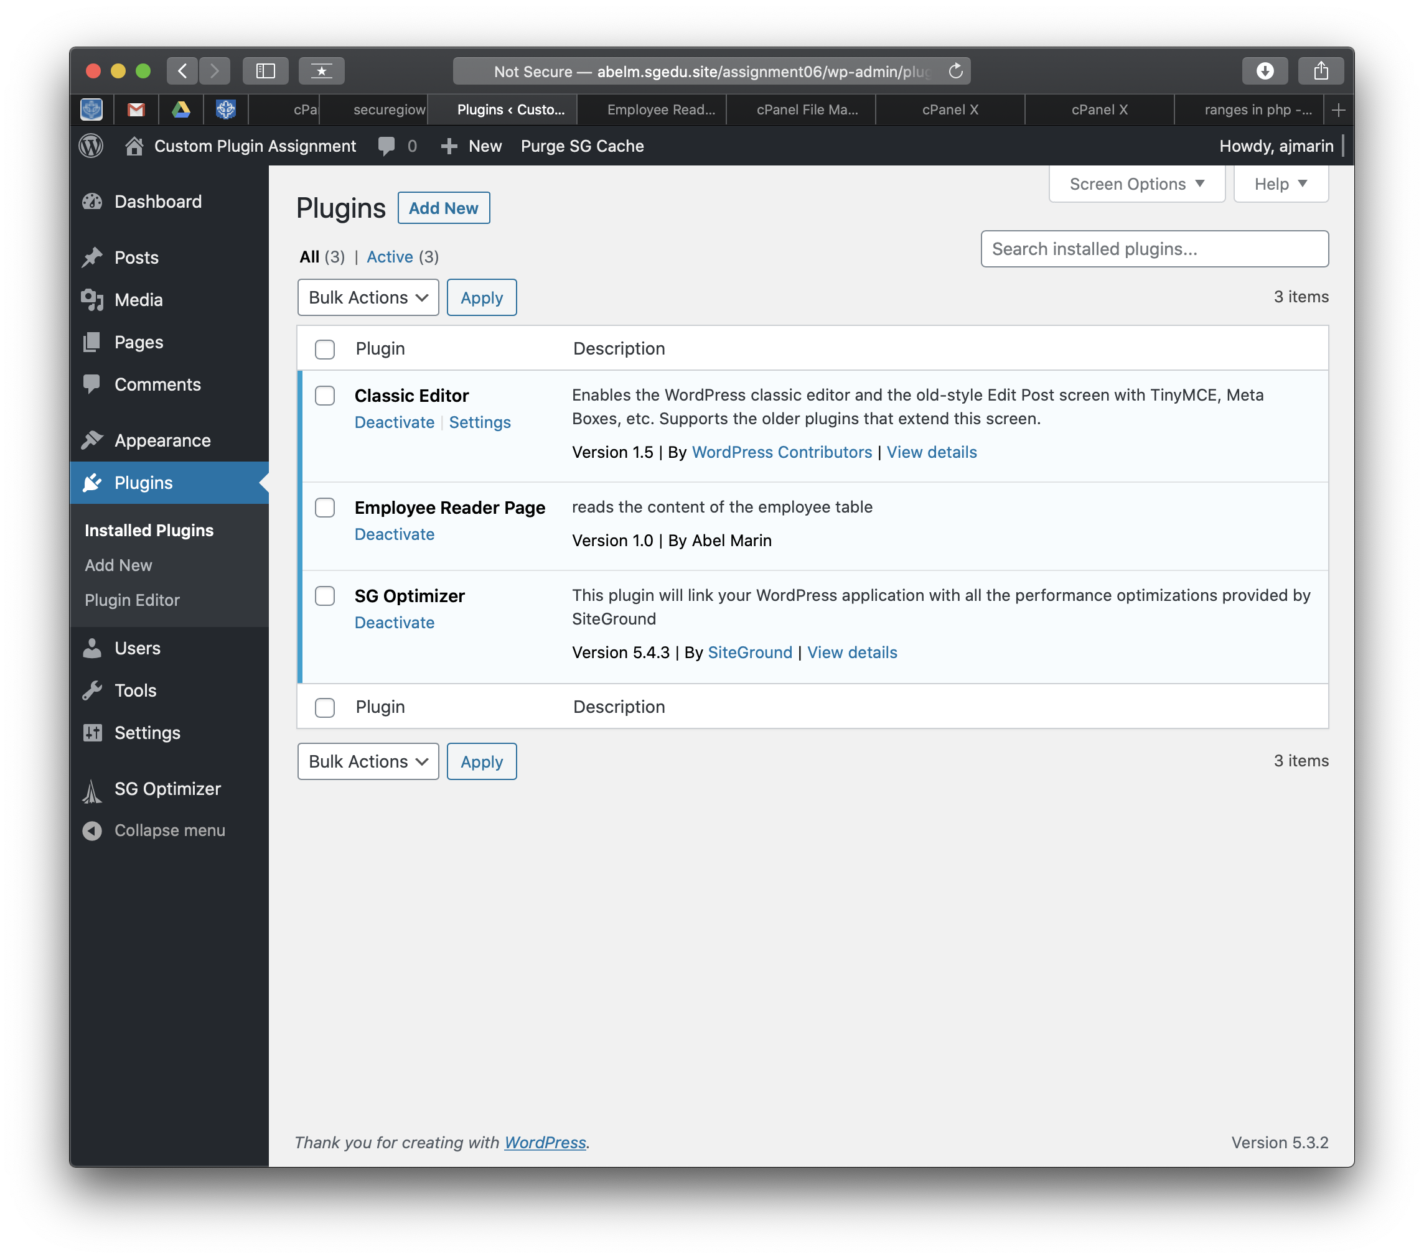]**

**2. Take a** SCREEN CAPTURE of the **backend** **[Dashboard > Themes > Menus] [F02]  
[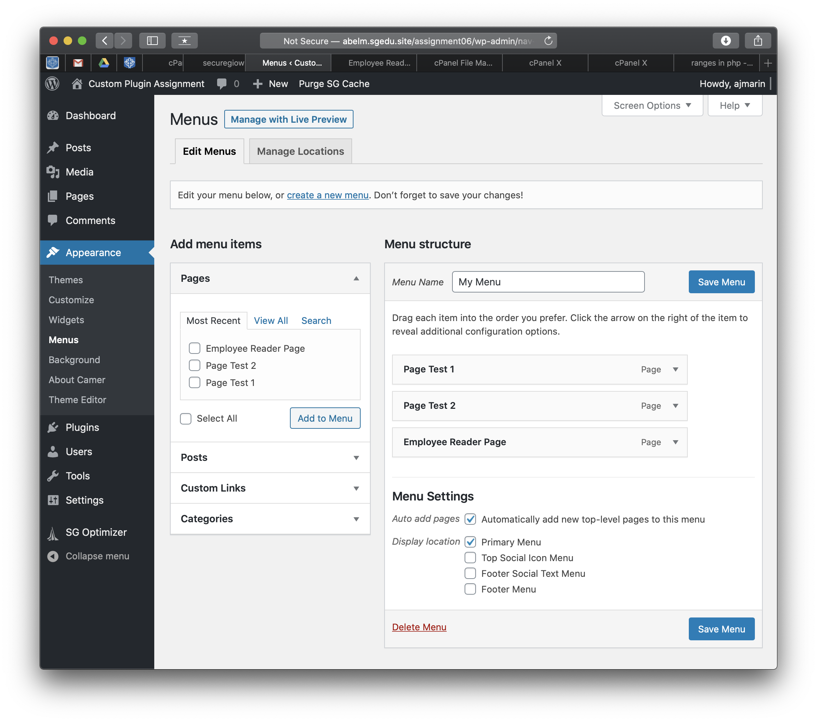]**

**2. Open the custom plugin code in an ASCII editor and take as many screen captures as you need to capture the entire PHP file contents. Paste the** SCREEN CAPTURES of the **custom Plugin in the area below [F03]  
[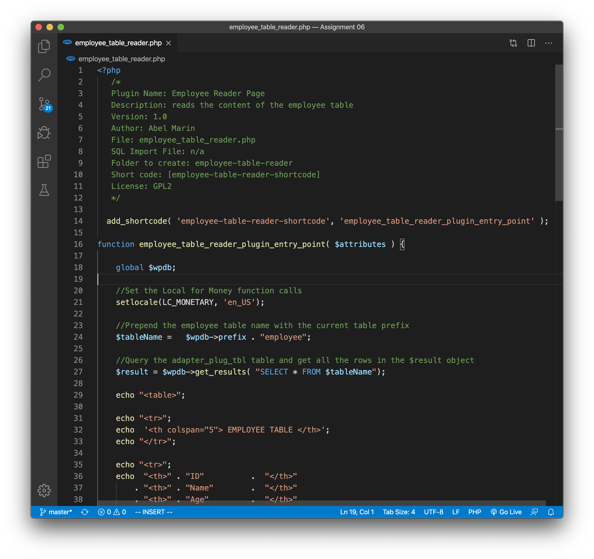]   
[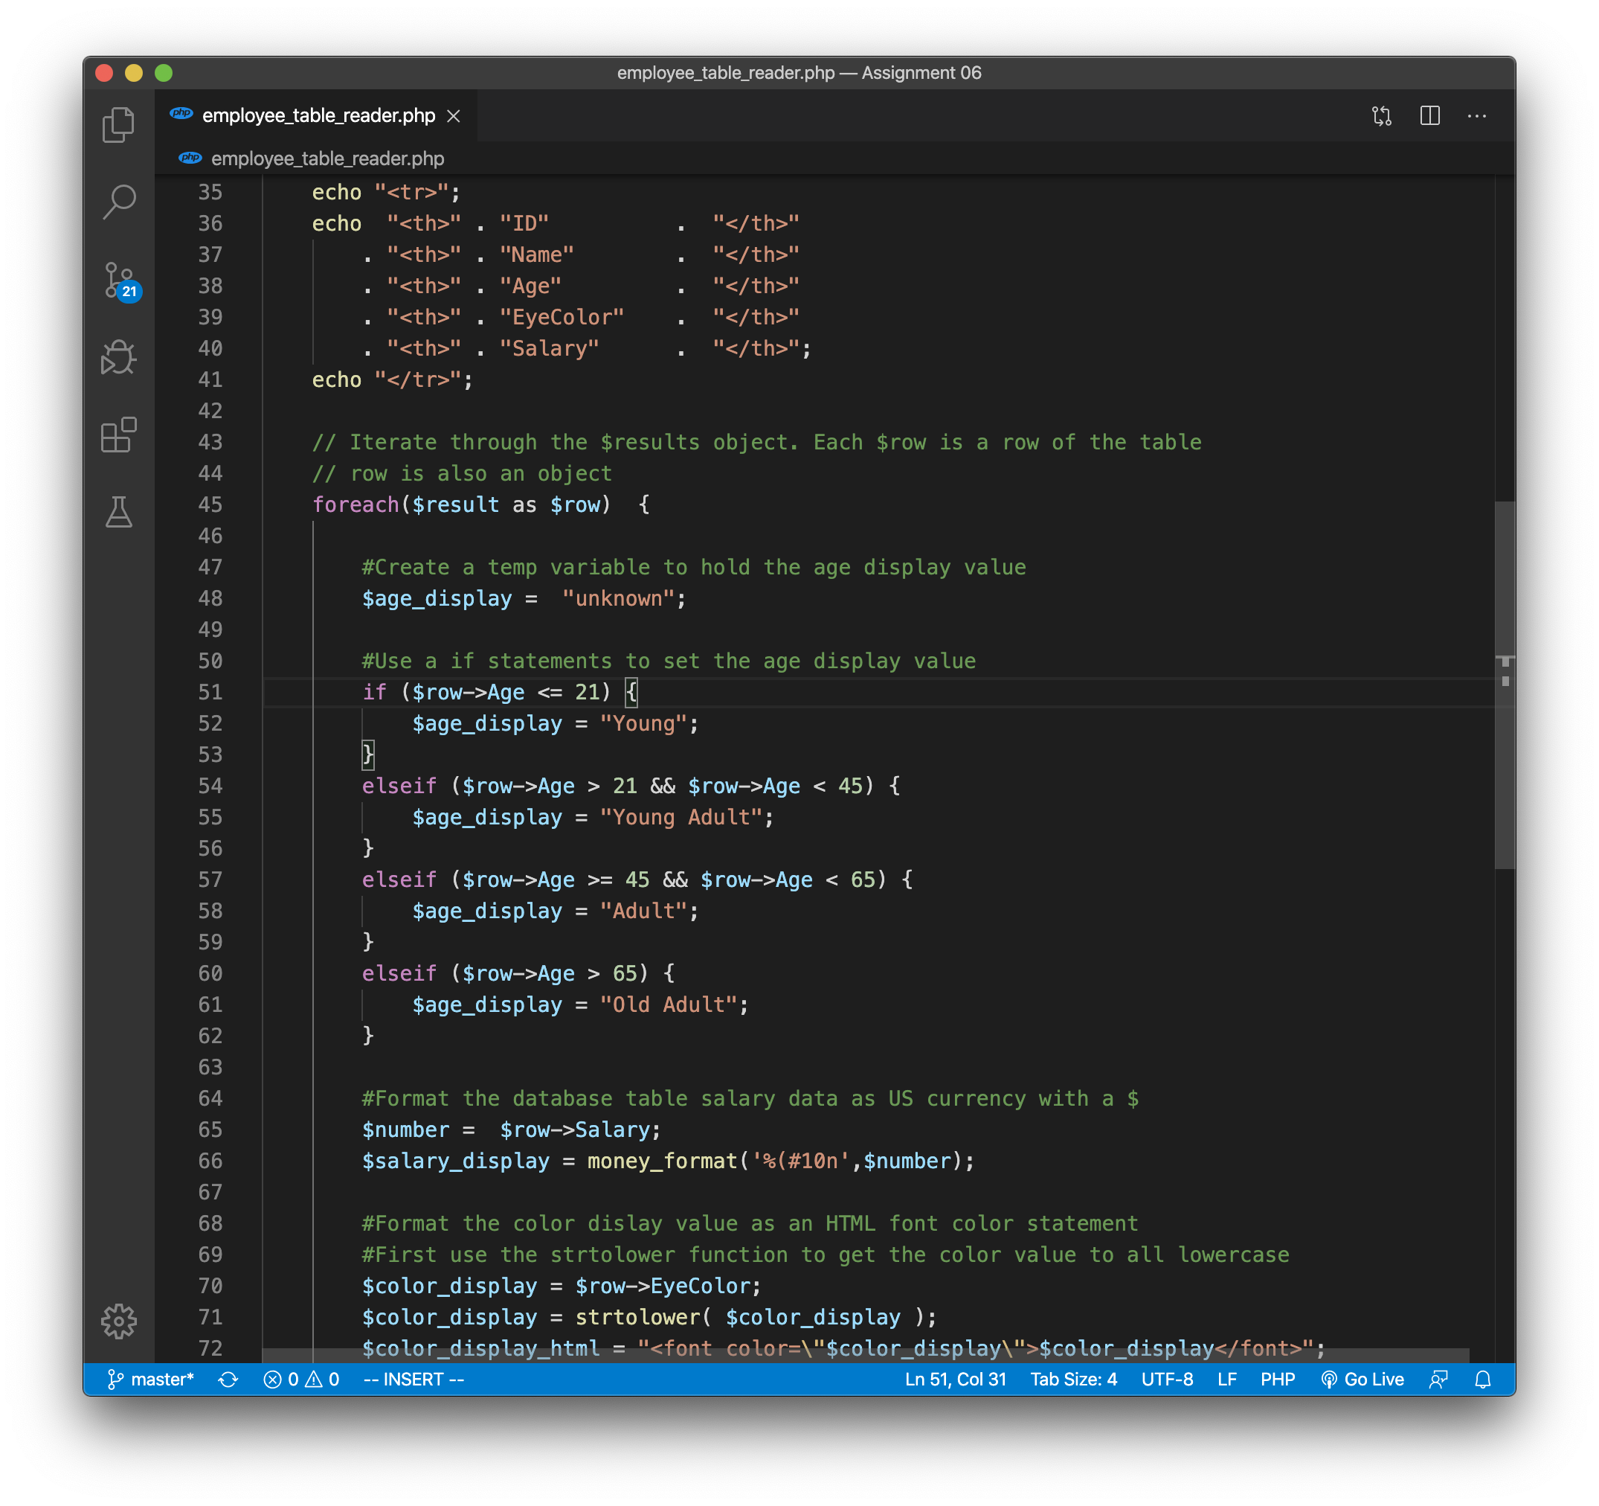]  
[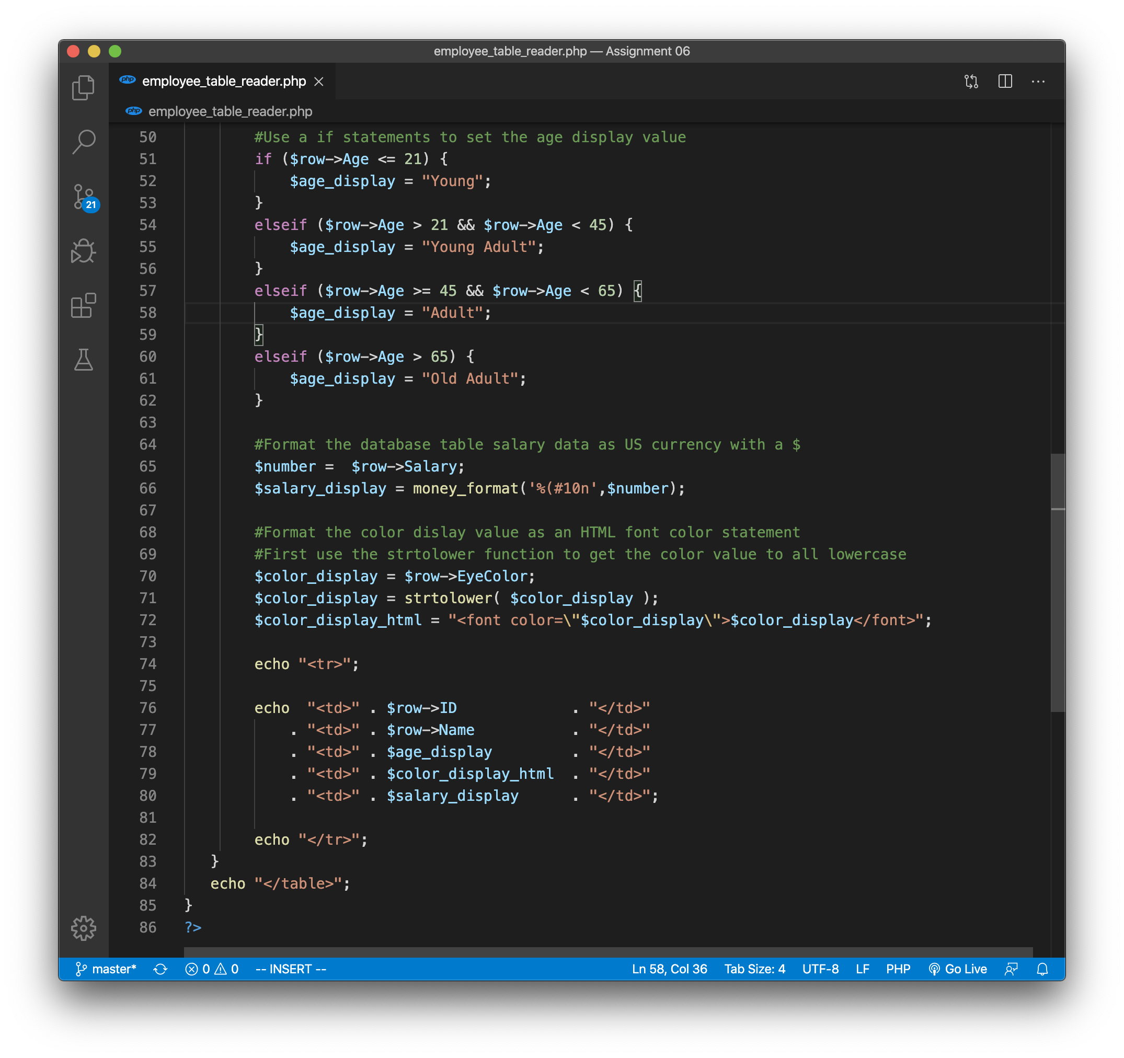]  
[SCREEN CAPTURE(S) HERE]**

**3. SCREEN CAPTURE of the frontend** of the website showing your working custom plugin selected from the menu**[F04]  
[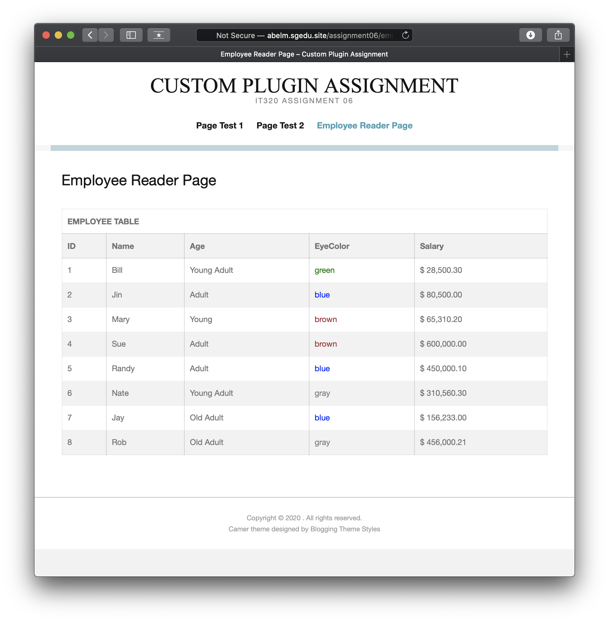]**

**Go back to the instructions and begin work on part G.**

**Part G – Assignment Wrap up:**

1. **Did you have any problem or issues completing this assignment?  
   This is not an optional question.   
   [No] [F01]  
     
   If you answered yes to this question, please elaborate and be specific.  
   If you had trouble with a specific question, please identify it by number and explain what you did not understand or had problems with.  
   I can only improve this assignment with your help.**

**[List problems here] [F02] *Only if you answered yes to #2**

Submit this completed template to the correct D2L assignment dropbox.If you prefer not to navigate by hand to the D2L dropbox, take advantage of the dropbox link in the D2L this module’s section. This link will take you to the correct assignment dropbox location.